SCHOOL OF FOREIGN LANGUAGES

2022-2023 SPRING TERM

ERASMUS ENGLISH EXAM
03.05.2023
60 mins
AAA

Name / Surname: ………………………………………………………
Department: ……………………………………………………………
Number: ………………………………………………………………..
Score: …………………………………………………………………..

SECTION 1: LISTENING (6x 3 =18 points)

Questions 1 – 7: Circle the best answer to these questions while you listen. You will listen twice.

1. Barbara invites Mike_______ .

a) to the cinema b) to a concert c) for a picnic

2. John’s going to write the covering letter_____ .

a) tomorrow b) on Friday c) on Wednesday

3. Alice’s grandmother didn’t use to dance _______ when
she was younger.

a) the twist b) rock ‘n’ roll c) salsa

4. Ken’s not a very good manager because he’s_______ .

a) competitive b) indecisive c) hard-working

5. Maggie can take Dave to the station because she’s
starting work at_______ .

a) 10 a.m. b) 8.35 a.m. c) 15 a.m.

6. When is Kate’s birthday?

a) 24th May b) 25th May c) 26th May

SECTION 2: USE OF ENGLISH (12x3 = 36 pts)
Questions 7-18: Find the correct words to complete the paragraph. Choose A,B,C or D.
Living in a New Country

Although living in another country can be an (7) ___________________ adventure, it is sometimes proves (8) ___________________ a difficult experience. Many things are new and different – not only the language and culture but also (9) ___________________ things like where to buy stamps or when banks are open. For a person who is used (10) ___________________ in control of their world these new experiences can make them feel helpless, (11) ___________________ and frustrated.
Many of those who start a life somewhere else often go through certain (12) ________________ before they feel at home in their new (13) ___________________. The first few weeks after arrival in another country is full of positive feelings and excitement. Then (14) _______________ sets in and can make you feel angry and impatient. Some people (15) ___________________ their new home for such feelings. Eventually, however, most newcomers settle (16) _________ and begin to adapt.
However, when a person returns to their own culture, they may (17) ___________________ the same things in reverse. It takes them (18) ___________________ time to get back to their former life in their home country.

7. A excited B exciting C pleasure D thrilled
8. A have been B be C of being D to be
9. A everyday B each day C average D regular
10. A been B to being C to be D being
11. A confusing B confused C confuse D confusion
12. A steps B times C eras D stages
13. A surroundings B settings C atmospheres D situations
14. A life B certainty C reality D truth
15. A cause B blame C accuse D hold
16. A in B off C of D back
17. A bear B happen C suffer D experience
18. A some B any C every D all

SECTION 3: READING (12x3= 36pts)

Reading 1
Questions 19– 23: Read the messages and notices and underline the correct answer, a), b) or c).

19.
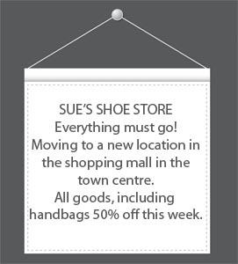

A. You need to buy shoes from the shopping mall in town today.
B. This shoe store will no longer serve customers after this week.
C. Only handbags are available at a reduced price this week.
20.
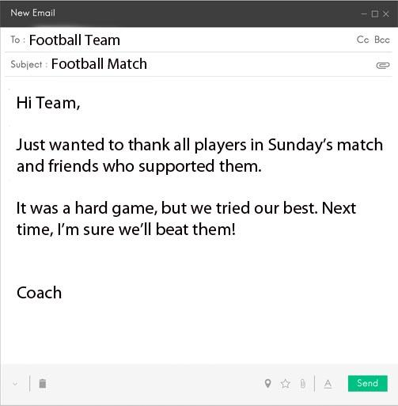

What is the coach doing?
A. Encouraging the team to play even better in a future match.
B. Congratulating the team on their most win.
C. Letting the team's fans know the positive effect of their support.
21.
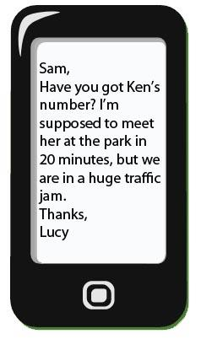

A. Lucy needs to let Ken know she's probably going to be late.
B. Lucy's not sure when she's supposed to meet Ken at the park.
C. Lucy wants Sam to contact Ken and warn him about traffic problems.

22.
LA CANTINA RESTAURANT
Why not enjoy a pizza with your friends?
This week only-special on super Super Supreme pizzas.

A. The Super Supreme is only available this week.
B. Choose which size of pizza and still get a special price.
C. Pay less at the moment for a certain pizza.

23.
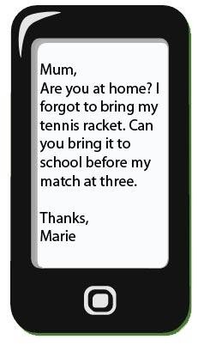

A Marie is asking if her mum has found her tennis racket.
B Marie needs her tennis racket so she can play tennis this afternoon.
C Marie is asking her mum to watch the tennis match.

Reading 2
Questions 24 – 30: Choose the correct answer A, B, or C.
How to spot fake news
Every time you're online, you are bombarded by pictures, articles, links and videos trying to tell their story. Unfortunately, not all of these stories are true. Sometimes they want you to click on another story or advertisement at their own site, other times they want to upset people for political reasons. These days it's so easy to share information. These stories circulate quickly, and the result is … fake news.
There is a range of fake news: from crazy stories which people easily recognise to more subtle types of misinformation. Experts in media studies and online psychology have been examining the fake news phenomenon. Read these tips, and don't get fooled!
1. Check the source
Look at the website where the story comes from. Does it look real? Is the text well written? Are there a variety of other stories or is it just one story? Fake news websites often use addresses that sound like real newspapers, but don't have many real stories about other topics. If you aren't sure, click on the 'About' page and look for a clear description of the organisation.
2. Watch out for fake photos
Many fake news stories use images that are Photoshopped or taken from an unrelated site. Sometimes, if you just look closely at an image, you can see if it has been changed. Or use a tool like Google Reverse Image search. It will show you if the same image has been used in other contexts.
3. Check the story is in other places
Look to see if the story you are reading is on other news sites that you know and trust. If you do find it on many other sites, then it probably isn't fake (although there are some exceptions), as many big news organisations try to check their sources before they publish a story.
4. Look for other signs
There are other techniques that fake news uses. These include using ALL CAPS and lots of ads that pop up when you click on a link. Also, think about how the story makes you feel. If the news story makes you angry, it's probably designed to make you angry.
If you know these things about online news, and can apply them in your everyday life, then you have the control over what to read, what to believe and most importantly what to share. If you find a news story that you know is fake, the most important advice is: don't share it!

24. Which reason is NOT given for an online fake news story?

a. To convince people of a political view
b. To make people angry or sad
c. To plant a virus in your computer

25. The text says some fake news …

a. is easy to recognise as fake.
b. is funny.
c. comes from the political right.

26. Which of these may mean that a news site should not be trusted?

a. The text is well written.
b. The site has a variety of other stories.
c. The site’s ‘About’ page does not clearly describe the organisation.

27. Some images on fake news …

a. are real images, but come from a different website.
b. are images that have been changed.
c. both the above

28. Fake news stories …

a. are usually only on fake news sites or social media.
b. are not on any websites, only in social media.
c. are often hidden on real news sites.

29. Many fake news stories are written …

a. without capital letters and with terrible spelling.
b. in a way that makes people upset.
c. inside of advertisements that pop up on your screen.

30. What is the purpose of this article?
a. To complain
b. To inform
c. To entertain

SECTION 4: WRITING (10 points)
………………………………………………………………………………………………………………………………………………………………………………………………………………….…………………………………………………………………………………………………………………………………………………………………………………………………………………………………………………………………………………………..……………………………………………………………………………………………………………………………………………………………………………………………………………………………………………………………………………………………………………………………………………………………………………………………………………………………………………………………………………………………………………………………………………………………………………………………………………………………………………………………………………………..
Write a review of a restaurant that you
have been to.
Use the ideas below to help you
-What was the restaurant like?
-What did you order?
-How was the food and service?
-Was the meal worth the money you paid?
-Would you recommend the restaurant?
(Why/why not?)

This is the end of the test.

 | A | B | C | D |  |  | A | B | C | D
1 |  |  |  |  |  | 16
2 |  |  |  |  |  | 17
3 |  |  |  |  |  | 18
4 |  |  |  |  |  | 19
5 |  |  |  |  |  | 20
6 |  |  |  |  |  | 21
7 |  |  |  |  |  | 22
8 |  |  |  |  |  | 23
9 |  |  |  |  |  | 24
10 |  |  |  |  |  | 25
11 |  |  |  |  |  | 26
12 |  |  |  |  |  | 27
13 |  |  |  |  |  | 28
14 |  |  |  |  |  | 29
15 |  |  |  |  |  | 30

