|  |
| --- |
| batman üniversitesi ile ilgili görsel sonucuAçıklama: Kapak Resmi  Journal of Engineering and Technology  ttp://dergipark.gov.tr/bundles/ojsdergipark/images/dergipark_logo_tr.png |
| Journal of Engineering and Tecnology 1 (2017) 1-6 |

Tachogenerator DC Motor Speed Control with PID and Fuzzy Logic

aAhmet Top, bOzan Çakmak, cMuammer Gökbulut

a,cFırat University, Faculty of Technology, Department of Electrical and Electronics Engineering, 23119, ELAZIĞ/TURKEY

bOndokuz Mayıs University, Yeşilyurt Demir Çelik Vocational High School, Department of Electrical and Energy Technologies, 55300, SAMSUN/TURKEY

a atop@firat.edu.tr,

|  |  |  |
| --- | --- | --- |
| A R T I C L E I N F O | A B S T R A C T | |
| *Article history:*  Received 16 December 2017  Received in revised form  26 December 2017  Accepted 27 December 2017  Available online 29 February 2017 | | In this study, closed loop speed control of a DC motor was performed using PID and fuzzy logic control methods. The speed information of the DC motor was taken from the tachogenerator and was transferred to Arduino Due microcontroller card with feedback. Experimental results showing the performance of the control systems were obtained by plotting in Matlab program of the data received via the serial port of the Arduino IDE program. These two control methods have been compared in terms of performance criteria such as rise time, sitting time and steady state error.  2017 Batman University. All rights reserved |
| *Key words:* ArduinoDC motorPIDFuzzy logic control * Corresponding author.  E-mail address: atop@firat.edu.tr | |

1. **Introduction**

DC motors can be fed directly from the DC power supply. As these motors are very simple and compatible with steady control methods, they are used in many applications such as manufacturing devices and industrial robots. Another advantage of them is their high efficiency and high starting torque in any sudden increase of load [1]. However, some disadvantages of these motors include necessary periodical maintenance, mechanical abrasion of outputs in a short time, acoustic noise, sparking, deficiencies in areas such as the impact of brush on efficiency. These problems were eliminated with the production of brushless DC motors [2]. DC motors are also preferred due to their advantages such as noiseless operation, no requirement for maintenance, fast dynamic response, good torque characteristic and efficient operation [3]

In a study performed by Kocaoğlu S. and Kuşçu H., they aimed to determine the required PID parameters for speed and position controls of a DC motor by using a PIC series microcontroller. Firstly, they attained and examined the motor parameters and observed the results with an experiment. As a result, the motor was controlled in the desired reference values against the PID parameters entered and the system became usable as an experiment set [4].

Bulut M., Kurt B. and Demirtaş M. designed a proportional-integral (PI) type fuzzy controller to perform the speed control of a direct-current motor. It was understood from the results that the performance of a controller designed automatically via genetic algorithms was better compared to human knowledge-based controllers [5].

Akyazı, Ö., Zenk H. and Akpınar A.S. studied the effects of various membership functions (triangular, trapezoidal, gaussian, cauchy, bell-shaped) used in fuzzy logic control in a study conducted on a permanent-magnet direct current motor. According to their results, the most number of errors were seen in bell-shaped membership function, best results were observed in triangular and trapezoidal membership functions and others yielded average results [6].

Köse F., Kaplan K. and Ertunç M. performed the speed control of a permanent-magnet DC motor with PID and fuzzy logic by using STM32F407 Discovery development kit and examined the differences. Results showed that both systems produced similar steady state errors, however, fuzzy logic controllers were observed to have higher overshoot, shorter rise time and later sitting time [7].

Huang G. and Lee S., DC designed a LabVIEW based PID controller for speed control of the motor and used VisSim's software simulation for response analysis. Firstly, they designed the motor driver circuit and then used photosensor and 8051 module for feedback information. They concluded that the simulation results were very compatible with the theoretical predictions [8].

Atef Saleh Othman Al-Mashakbeh developed the mathematical model of a brushless DC motor and simulated it by using Matlab/Simulink software package. He used Ziegler-Nichols method and PID control for speed control of the motor. According to his results, 71% overshoot was seen prior to adding PI control; however, after adding PI control, this overshoot disappeared and motor reached the reference value successfully [9].

In this study, closed loop speed control of direct-current motor was performed with PID and fuzzy logic controllers and experimental results were compared in terms of performance criteria such as overshoot, rise time, sitting time and steady state error.

1. **Control System**
   1. **PID Control**

PID controllers are composed of three basic controls and the control signal u(t) is calculated as:

$u\left(t\right)=Kp.e\left(t\right)+Ki.\int_{0}^{t}{e\left(t\right).d\left(t\right)+}Kd.\frac{d}{dt}.e(t)$ (1)

This controller generally has an effect on both transient and steady state control criteria. It is understood from the equation that, when Ki coefficient is zero the controller can be used as PD controller, and when Kd coefficient is zero it can be used as PI controller [10].

* 1. **Fuzzy Logic Control**

Fuzzy system processes the precise inputs used in non-fuzzy real systems in the basic unit shown in Figure 1 and consequently produces an output that can be used in non-fuzzy real applications.

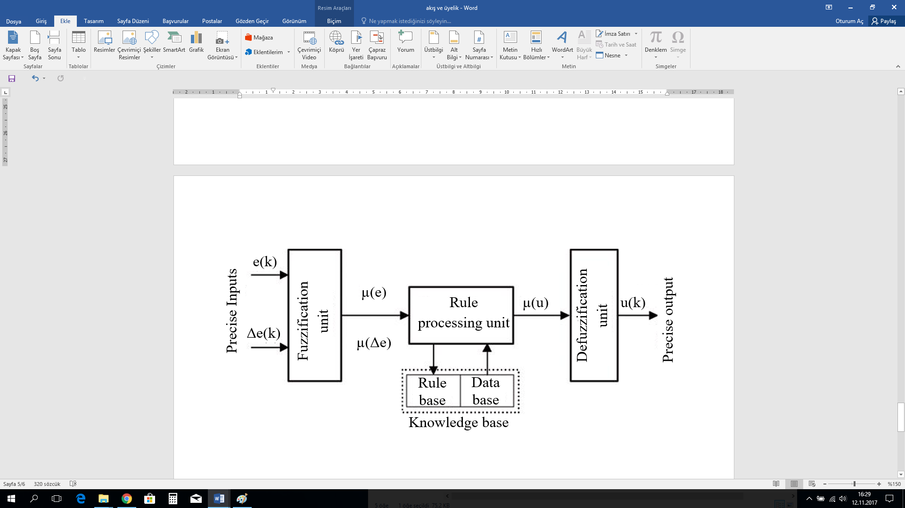

## **Figure 1.** Structure of fuzzy system

**Fuzzification Unit:**

It converts the precise values of fuzzy system inputs into fuzzy values with the help of membership function.

**Rule Base:**

Based on the knowledge of professionals specialized on the system, rule base is composed of IF and THEN rules that determine what kind of output should be produced against the incoming inputs.

**Inference Unit:**

Inference mechanism obtains a new fuzzy set by using the outputs of fuzzification unit -that is, the membership degrees of inputs- and the rule base.

**Defuzzification Unit:**

It converts the fuzzy output set obtained from inference unit into non-fuzzy real values to be used in application [11].

1. **Architectural Components of the System**
   1. **DC motor**

The motor used in the system is a brushed DC motor with 12V nominal voltage, 4090 rev/min no-load revolutions and 4W power [12]. For feedback information, two motors with the same properties were connected to each other from their shafts and used as a tachogenerator. When motors are operated at maximum 12 volts, approximately 11. 6 volts is generated from tachogenerator output ends.

* 1. **Motor driver, power supply and microcontroller**

Due to one-way speed control of the motor, driving process was performed with one MOSFET. Since the microcontroller used had low output voltage, two transistors were used for the control of MOSFET.

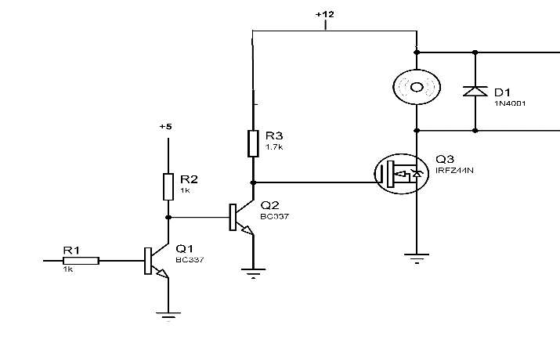

## **Figure 2.** DC motor driver

Power supply given in Figure 3 was built for feeding the motor, microcontroller and driver. This power supply can provide +-12V, 9V ve +5V DC.

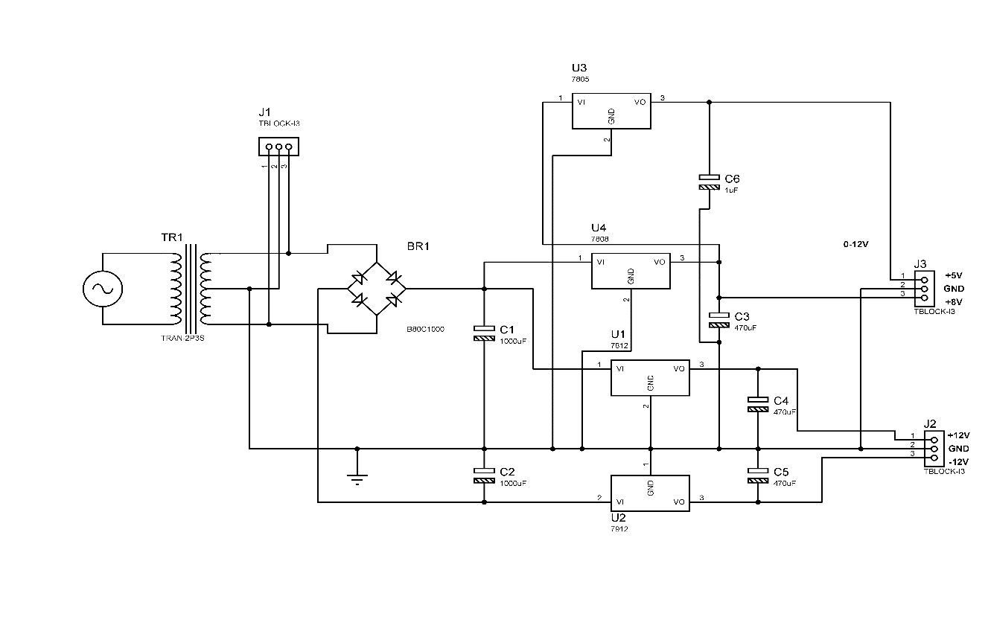

## **Figure 3.** Power supply

1. **Control of Tachogenerator DC Motor**
   1. **Effect of PID controller on DC motor control**

Motor voltage was increased linearly from 1 V with 1 V increments, the number of revolutions was measured for each value and entered into Matlab program, and a quadratic equation providing the information of voltage versus revolutions-per-minute was developed with curve-fitting method. Voltage information attained from tachogenerator was used in this equation via microcontroller and instantaneous revolutions data was calculated.

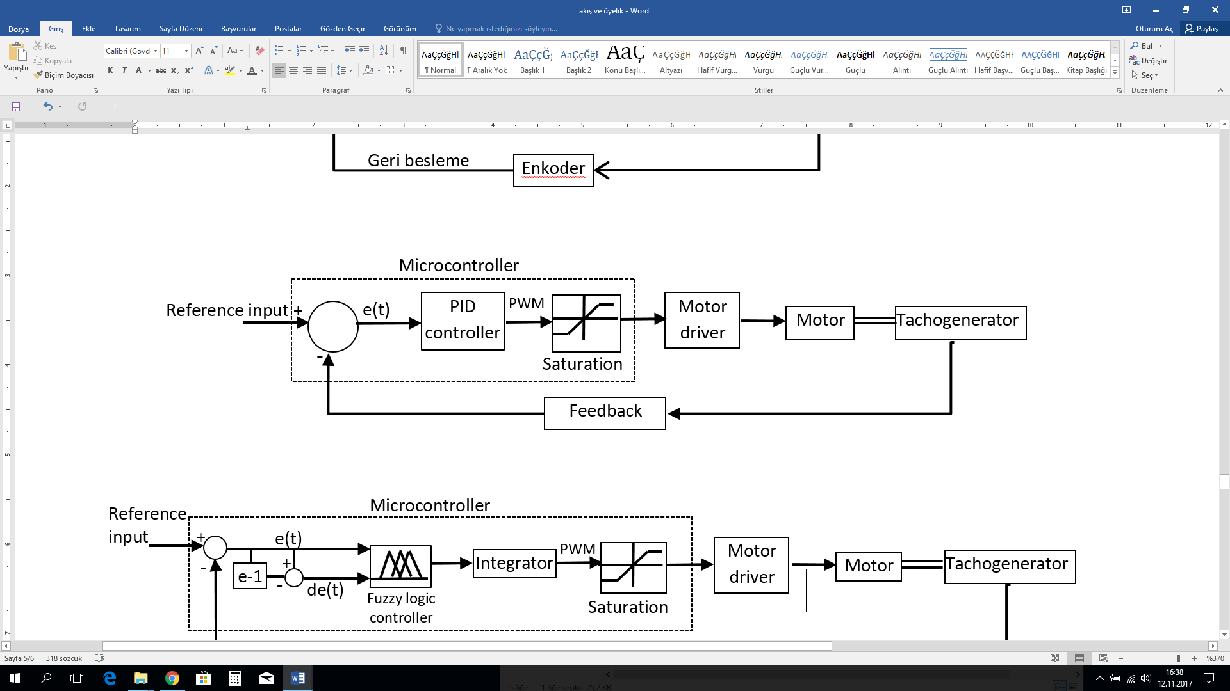

## **Figure 4.** PID control block diagram

As shown in the block diagram in Figure 4, the difference of reference value entered and feedback value attained from tachogenerator was taken and processed through PID algorithm and saturation. A PWM value was sent to the motor driver as output information. Revolutions data was taken from the Arduino serial port and plotted in Matlab.

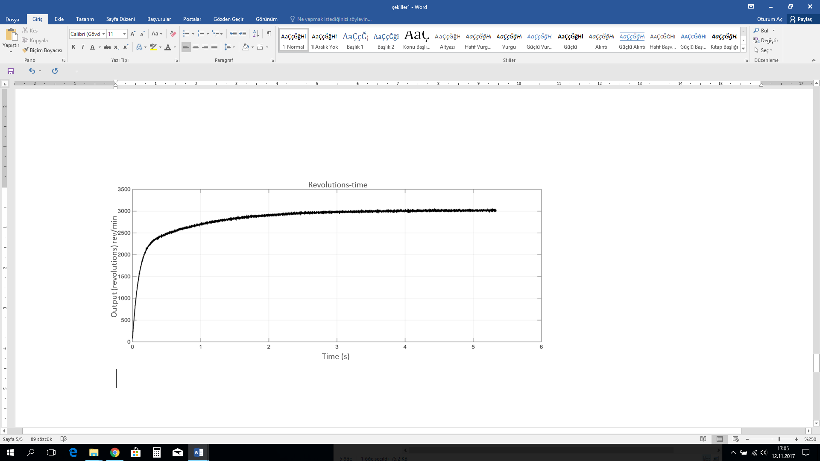

## **Figure 5.** Uncontrolled revolutions-time graph of DC motor

When the motor is operated without implementing any control method, steady state is reached within 5 seconds as shown in Figure 5. In this study, proportional and proportional + integral controller types were applied and the effects of various parameter values on system reaction were studied.

**Proportional Control (P):**

The speed control performance when proportional coefficient was selected as Kp=10 and motor reference value was adjusted to 3000 rev/min is given in Figure 6.



## **Figure 6.** Proportional control revolutions-time graph

As seen in Figure 6, when only proportional control was used, the system rapidly entered into steady state within 194.4 ms but steady state error occurred. It failed to reach the desired reference value and became steady at 2909 rev/min.

**Proportional+Integral Control (PI):**

In order to eliminate the steady state error occurring in proportional control, integral control was added to create PI controller. Parameters were set as Kp:26, Ki:5 and Kd:0 reference value was adjusted to 3000 rev/min.

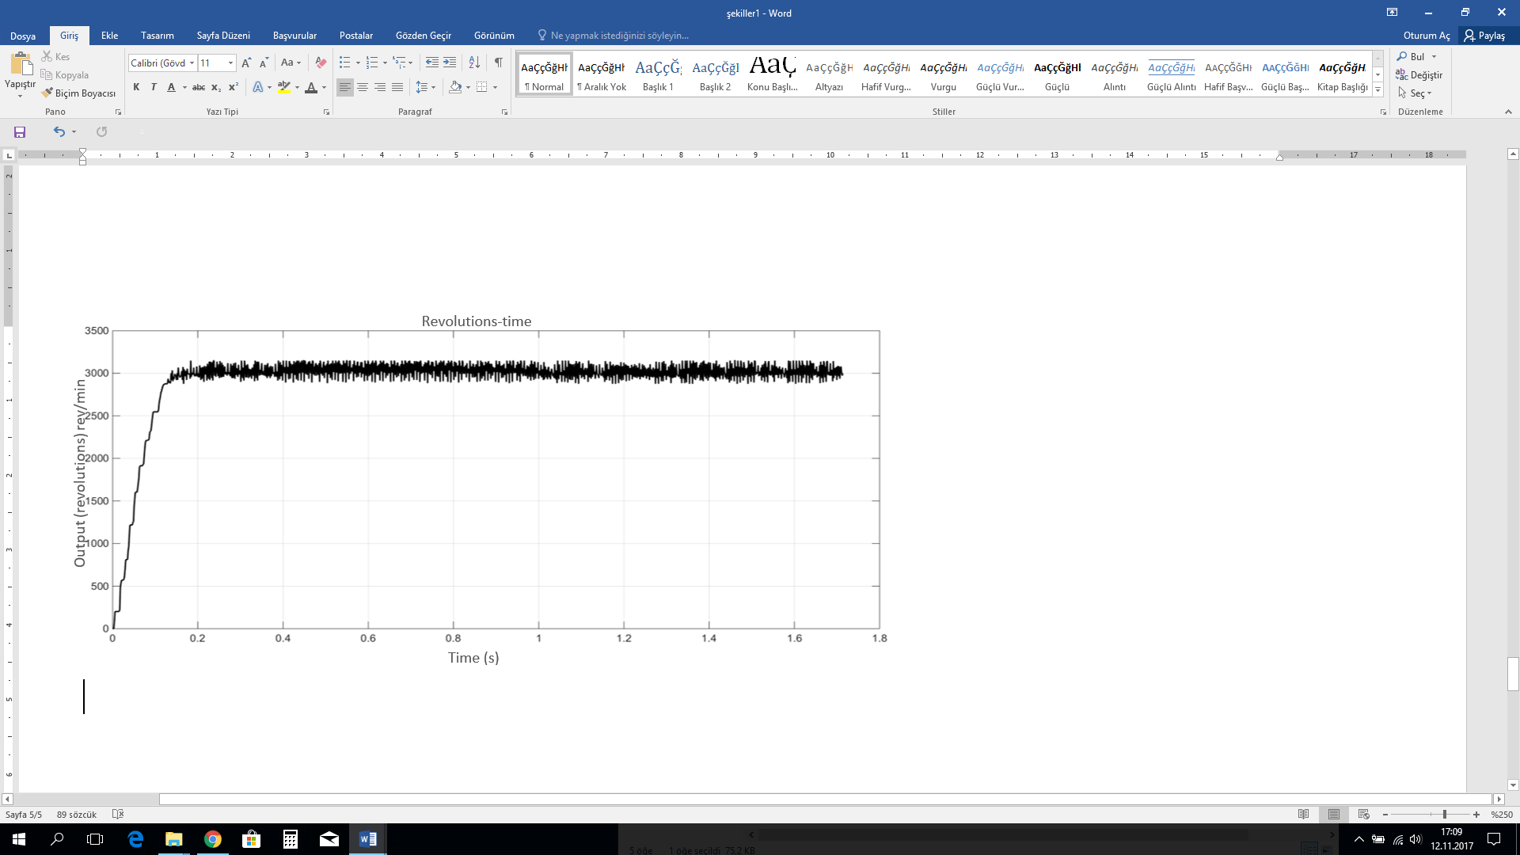

## **Figure 7.** Proportional + Integral control revolutions-time graph

In the figure above showing the revolutions-time graph of the motor, it is seen that steady state is reached within 140 ms without any errors.

* 1. **Effect of fuzzy logic controller on DC motor control**

Membership functions with two inputs and one output were generated for fuzzy logic control. While error and change in error were taken as inputs, PWM signal was produced as output. A block diagram of fuzzy logic controller is presented in Figure 8.

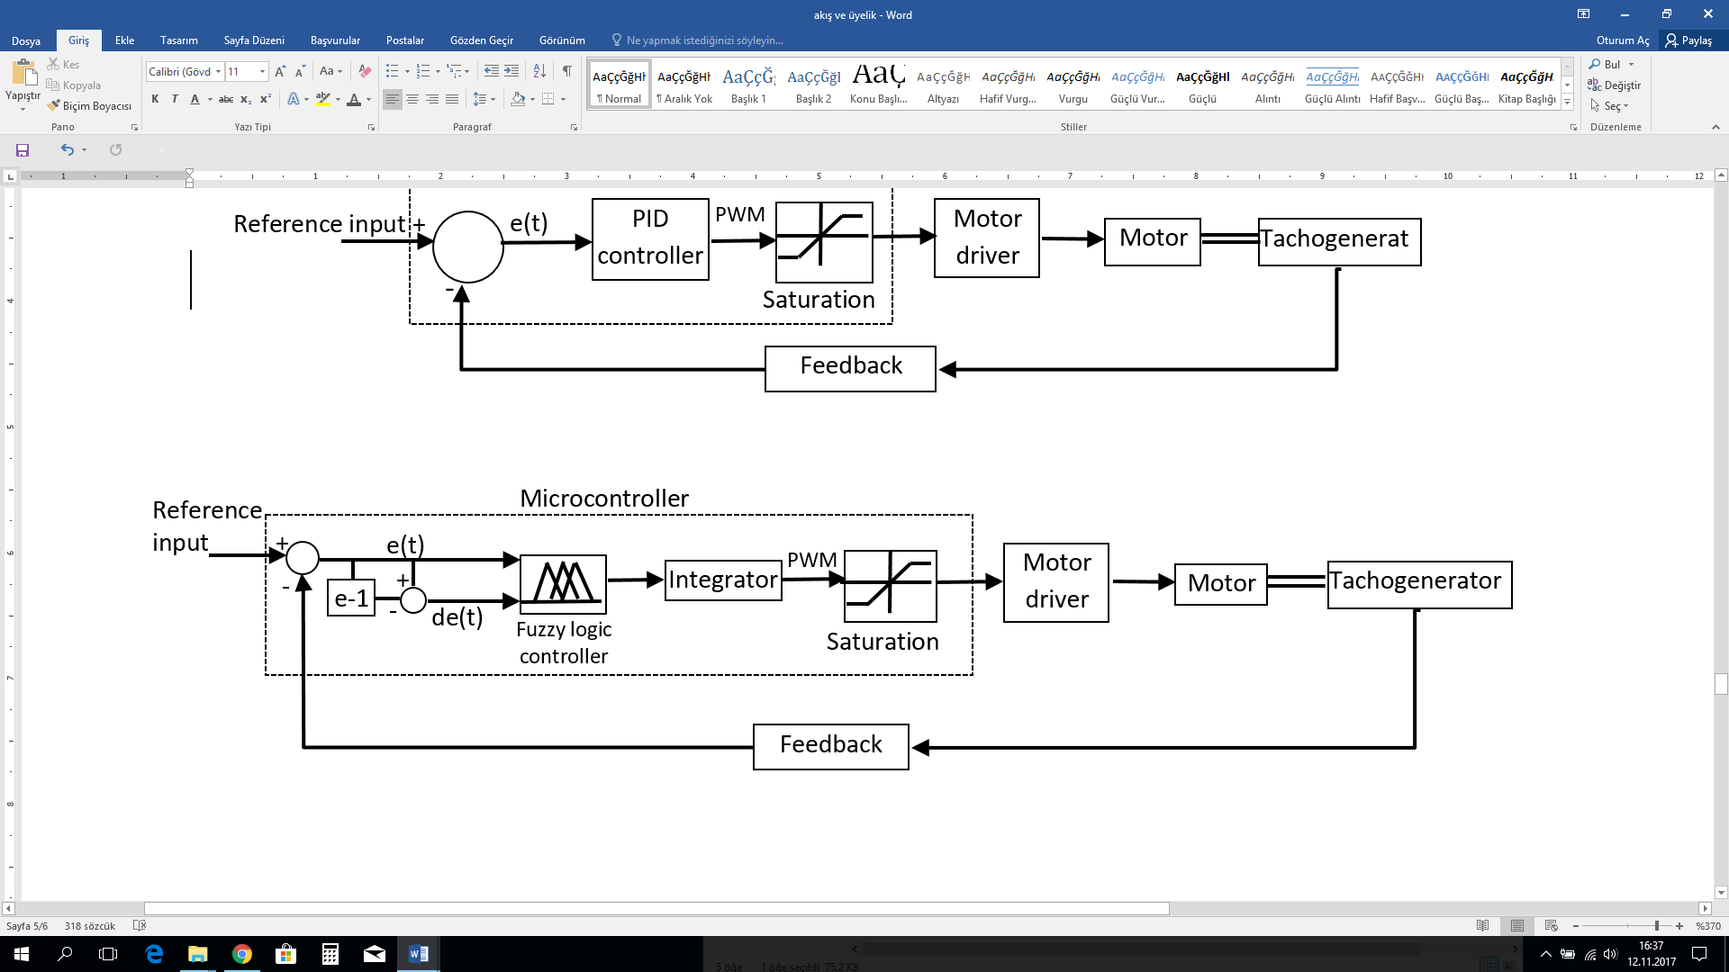

## **Figure 8.** Block diagram of fuzzy logic

Error (e) and change in error (de) between the set value and the revolutions data taken from tachogenerator were processed through functions, and membership degrees for the change in error were calculated. After both error and change in error were transferred to the sub-function for inference and defuzzification membership degrees and the output value was calculated, the result was processed through integrator and saturation and PWM output was produced.

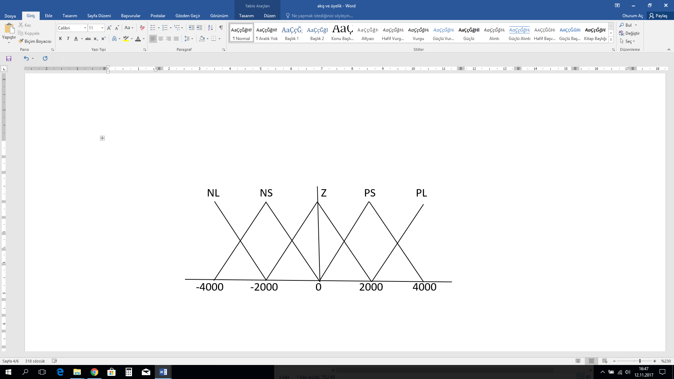

## **Figure 9.** Input membership functions

As seen in Figure 9, 5 triangular membership functions were used for the input. These membership functions were NL: negative large, NS: negative small, Z: zero, PS: pozitive small and PL: pozitive large. Motor speed was adjusted as maximum 4000 revolutions. These functions are applicable to both error and change in error.

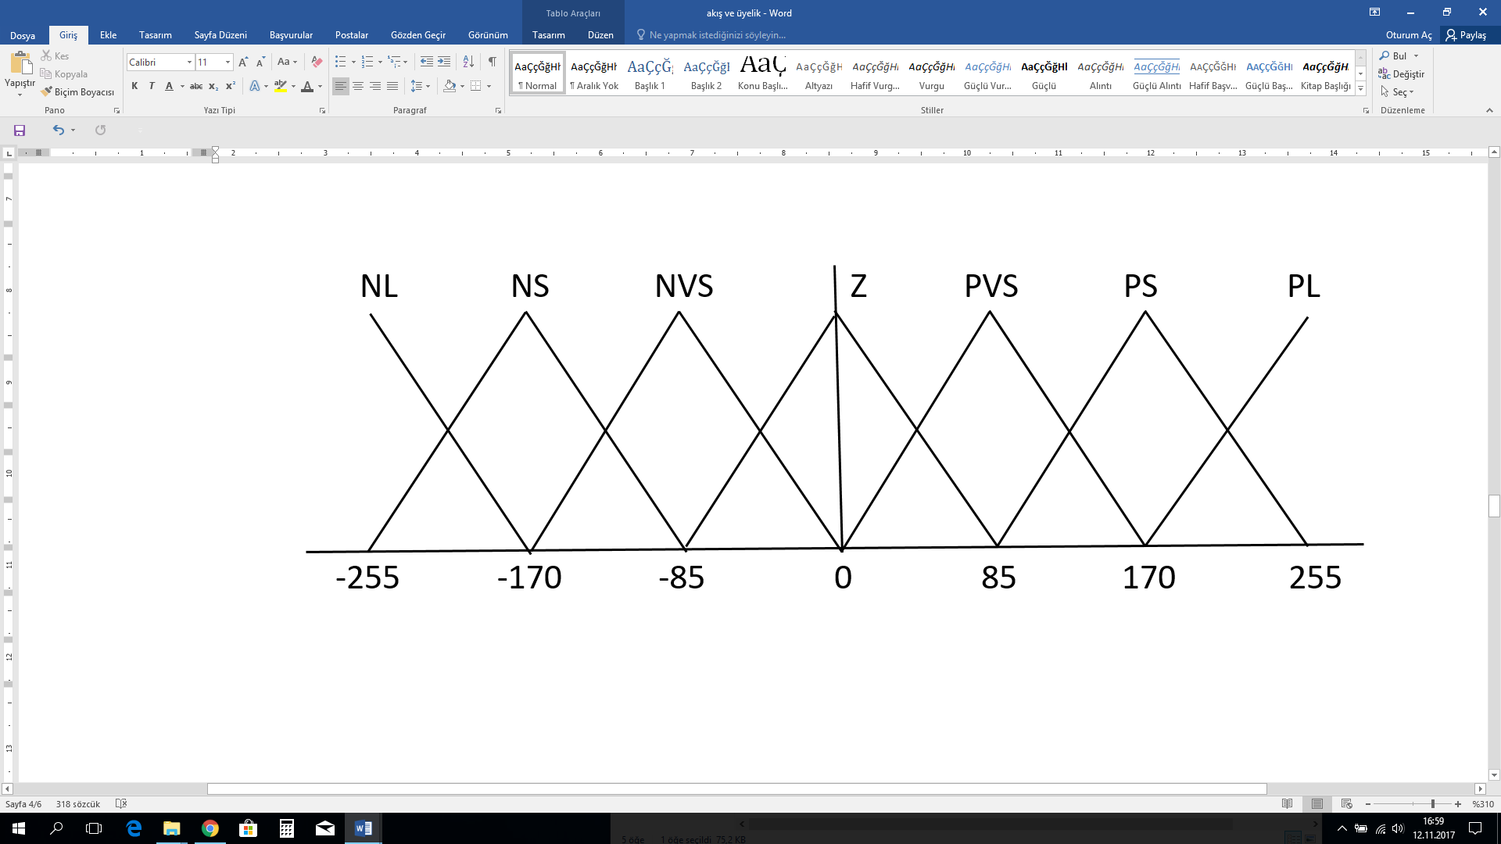

## 

## **Figure 10.** Output membership functions

As shown in Figure 10, 7 triangular membership functions were used for output membership functions. These membership functions are NL: Negative large, NS: Negative small, NVS: Negative very small, Z: Zero, PVS: Positive very small, PS: Positive small and PL: Positive large. Rule table used in inference mechanism is as given in Table 1.

## 

## **Table 1.** Rule base

|  |  |  |  |  |  |
| --- | --- | --- | --- | --- | --- |
| de  e | NL | NS | Z | PS | PL |
| NL | NL | NL | NS | NVS | Z |
| NS | NL | NS | NVS | Z | PVS |
| Z | NS | NVS | Z | PVS | PS |
| PS | NVS | Z | PVS | PS | PL |
| PL | Z | PVS | PS | PL | PL |

Fuzzy logic result obtained with weighted average method in defuzzification unit was transferred to the motor driver as PWM value.

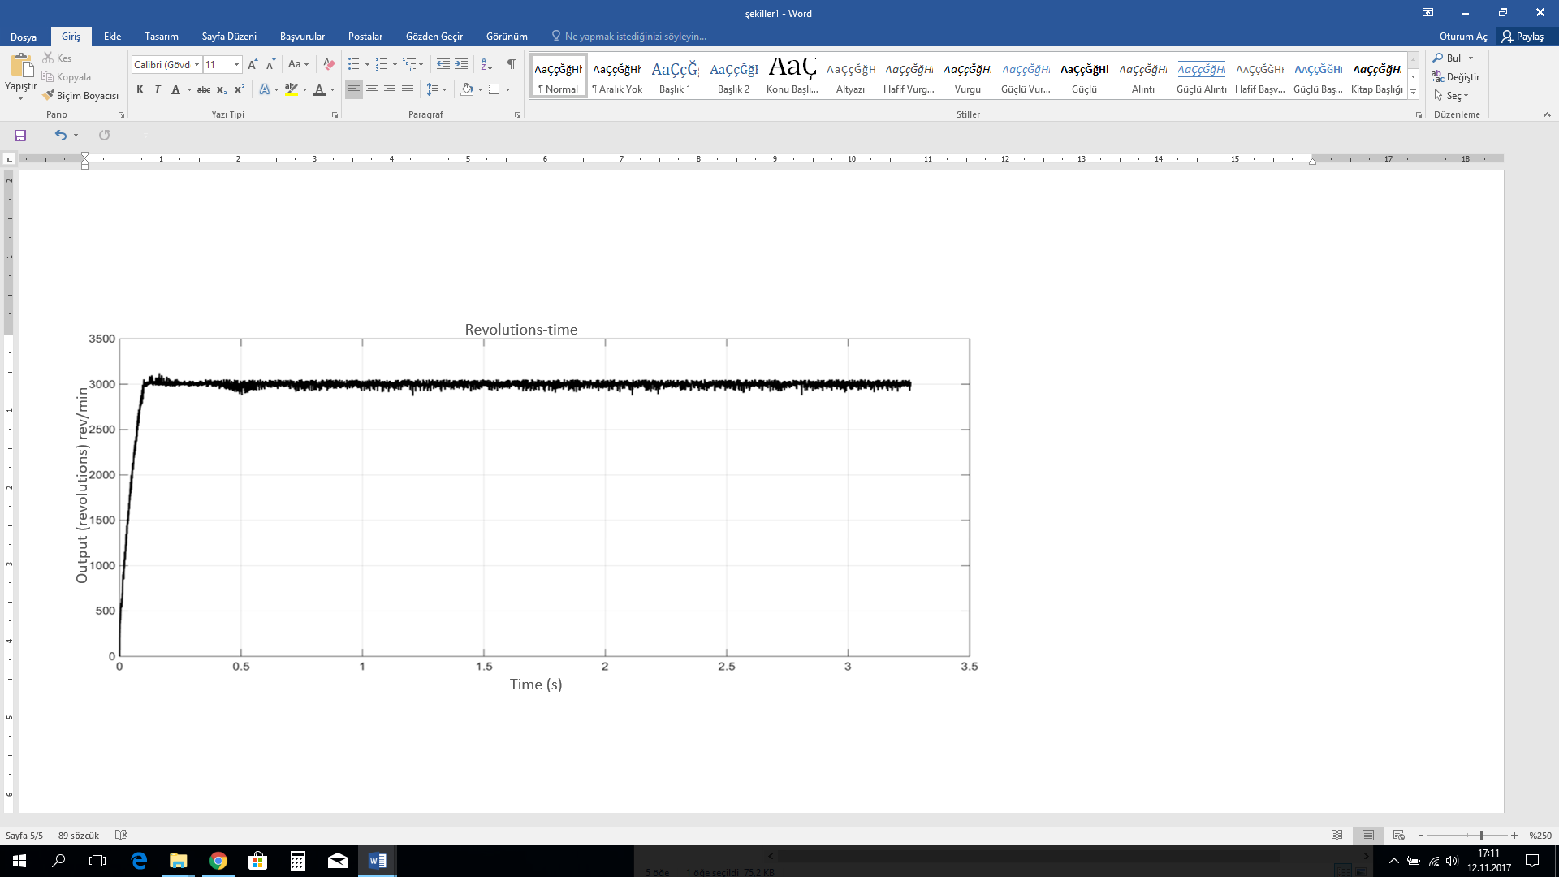

## **Figure 11.** Fuzzy logic controlled revolutions-time graph

When fuzzy logic control method was applied to the motor, it reached the reference value without errors within a time as short as 99.1 ms.

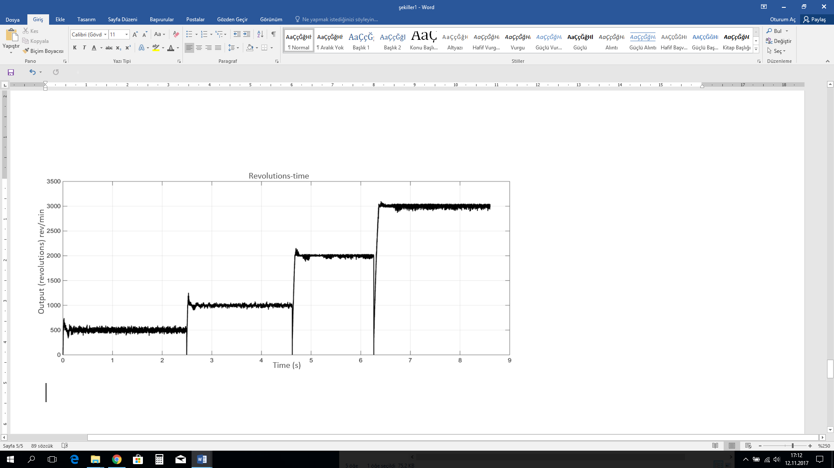

## **Figure 12.** Revolutions-time graph for various revolutions in Fuzzy Logic control

The motor was observed to follow the references without any problems when reference revolutions data of the motor was changed during operation. Reference values here are 500, 1000, 2000 and 3000 rev/min respectively.

1. **Conclusion**

The closed loop speed control of a direct current motor was performed with proportional + integral + derivative and fuzzy logic controllers in this study. When proportional control was used for motor control, no overshoot was observed but 91 rev/min steady state error occurred and steady state was reached within 194.9 ms. When PI controller was used to eliminate this error, it reached the set value within 140 ms with no overshoot and with almost no errors. Since there was no overshoot in the motor, derivative control was not required. When fuzzy logic control was applied, it reached the set value within 99.1 ms with no overshoot and with almost no errors in transient regime. Although steady state was reached in both control methods without any overshoot, better results were achieved in terms of rise time and sitting time in fuzzy logic control.

**Acknowledgement**

*This paper was previously published as a conference paper in “International Engineering Conference (IEC2017), October 2017”.*

**References**

[1] Siemens Training Education Program, STEP 2000 Series, “Basics of DC drives and related products”.

[2] Oguntoyinbo, O. (2009). PID control of brushless DC motor and robot trajectory planning simulation with MATLAB®/SIMULINK®.

[3] Yedamale, P. (2003). Brushless DC (BLDC) motor fundamentals. Microchip Technology Inc, 20, 3-15.

[4] Kocaoğlu, S. (2013). PID Kontrollü Top-Çubuk sisteminin tasarımı ve kontrolü üzerine bir araştırma.

[5] Bulut, M., Kurt, M. B., & Demirtaş, M. (2004). Genetik-Bulanık Kontrolörün DC Motora Uygulanması. Politeknik Dergisi, 7(4).

[6] Akyazı, Ö., Zenk, H., & Akpınar, A. S. (2011, May). Farklı Bulanık Üyelik Fonksiyonları Kullanarak Sürekli Mıknatıslı DA Motorunun Hız Denetiminin Gerçeklenmesi. In 6th International Advanced Technologies Symposium (IATS’11) (pp. 16-18).

[7] Köse, F., Kaplan, K., & Ertunç, H. M. (2013). PID ve bulanık mantık ile DC motorun gerçek zamanda STM32F407 tabanlı hız kontrolü. Otomatik Kontrol Ulusal Toplantısı, TOK2013, 26-28.

[8] Huang, G., & Lee, S. (2008, July). PC-based PID speed control in DC motor. In Audio, Language and Image Processing, 2008. ICALIP 2008. International Conference on (pp. 400-407). IEEE.

[9] Al-Mashakbeh, A. S. O. (2009). Proportional integral and derivative control of brushless dc motor. European Journal of Scientific Research, 35(2), 198-203.

[10] Gökbulut M., Kontrol sistemlerinin analiz ve tasarımı, Seçkin Yayıncılık, Ankara.

[11] Akpolat, H., Bulanık Mantık Ders Notları, Fırat Üniversitesi, Elazığ.

[12] Maxon DC motor Teknik datasheet, Nisan 2006.