THE TITLE OF THE STUDY SHOULD BE CENTERED AND IN TIMES NEW ROMAN, 14-POINT FONT SIZE
Name Surname¹, Name Surname²
¹Author’s Title, AAA University, BBB Faculty, CCC Department, City, Country, firstauthor@email.com, ORCID Information
²Author’s Title, AAA University, BBB Faculty, CCC Department, City, Country, secondauthor@email.com, ORCID Information

Abstract
The abstract should be written in 200 words maximum. The font should be Times New Roman, 9pt, single-spaced, and justified. After providing information about the article's main purpose/question and method, a brief evaluation of the findings and conclusion/recommendation should be made in the abstract. The abstract is expected to be a single paragraph. The abstract should be written in 200 words maximum. The font should be Times New Roman, 9pt, single-spaced, and justified. After providing information about the article's main purpose/question and method, a brief evaluation of the findings and conclusion/recommendation should be made in the abstract. The abstract is expected to be a single paragraph. The abstract should be written in 200 words maximum. The font should be Times New Roman, 9pt, single-spaced, and justified. After providing information about the article's main purpose/question and method, a brief evaluation of the findings and conclusion/recommendation should be made in the abstract. The abstract is expected to be a single paragraph. The abstract should be written in 200 words maximum. The font should be Times New Roman, 9pt, single-spaced, and justified. After providing information about the article's main purpose/question and method, a brief evaluation of the findings and conclusion/recommendation should be made in the abstract. The abstract is expected to be a single paragraph.

Keywords: 3 to 5 keywords will be written.

- INTRODUCTION
This section should state the study’s background, purpose, and importance. The introduction should help the reader understand the main purpose of the article.
- Section headings should be written in bold 12 points, capital letters, and justified. In heading numbers, numbers should be given starting from the introduction section and should be numbered in a decimal system (such as 1., 2., ...).
- Section subheadings should be written in bold 11 points, capital letters only, justified. In heading numbers, numbers should be given starting from the introduction section and should be numbered in a decimal system (such as 1., 1.1., 1.1.1.).
- In the main text, paragraphs should be in Times New Roman font and 11 points in size.
- Alignment; justified, indentation; left: 0 cm, right: 0 cm; special: The first line should be 1.25 cm. A 6 pt space should be left after paragraphs and the line spacing should be written as 1.15. Page numbers should be at the bottom right.

- METHOD
  - Study Area
This section should explain the methods and techniques used in the study. The steps should be clear and understandable.
- RESULTS AND DISCUSSION
The findings and analyses obtained should be presented in this section. Tables, graphs and other visual materials can be used in this section.

- CONCLUSIONS
The results are evaluated and the overall contributions of the study are discussed. Suggestions for future studies can be made.

Figure and Table Captions
Figure captions and table captions should be sufficient to explain the figure or table without the need for external references. Figure and table captions should be written in 10-point font. Figures and tables that are not cited in the text should not be presented. Tables and figures should be placed immediately after their first reference in the text. Figures and tables should be numbered. Table captions should be centered above the tables. Table 1 and Figure 1 are given as examples. Text within tables, figures, etc. should be in 10-point font.
Table 1. Drought Classification According to SSFI Values
SSFI Index Value | Classification | Abbreviation
2.0 and above | Extremely Wet | EW
1.5 to 1.99 | Very Wet | VW
1.0 to 1.49 | Moderately Wet | NW
-0.99 to 0.99 | Near Normal | NN
-1.0 to -1.49 | Moderately Dry | MD
-1.5 to -1.99 | Severe Dry | SD
-2.0 and below | Extremely Dry | ED

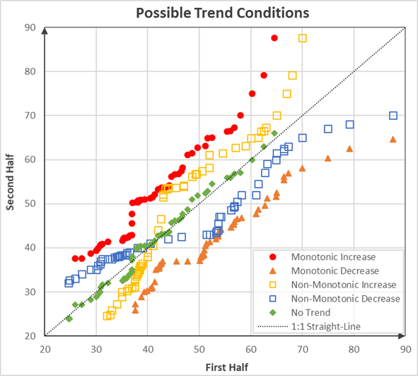
Fig. 1. Trend situations according to the ITA method

Equations
Each equation should be presented on a separate line from the text. Equations should be clear and the expressions used should be explained in the text. Equations should be numbered continuously on the outer right margin as follows:
$$\begin{aligned}SSFI=\frac{F_{i}-\overline{F}}{σ} \#\left(1\right)\end{aligned}$$
$$\begin{aligned}SSFI=\frac{F_{i}-\overline{F}}{σ} \#\left(2\right)\end{aligned}$$
References
Appropriate references should be included throughout the text and the reference list should be provided in this section. The references and reference list included in the text should be as follows:
IEEE Formatında Kaynakça Hazırlarken Dikkat Edilmesi Gerekenler
Numbering System:
References are numbered in the order they are used throughout the article. References cited in the text are numbered in square brackets. For example, when a study is mentioned, it is shown as: "[1]". The references are listed according to these numbers.
Formatting According to Source Type:
IEEE format uses a specific format for different types of sources, such as books, articles, conference proceedings, or internet sources. There is a special structure for each type of source:
Book:
Author(s) first and last name, Book Title, edition number (if any), publisher, place of publication, year of publication.
Example: J. K. Author, Book Title, 3rd ed. New York, NY, USA: McGraw-Hill, 2019.
Article:
Author(s) first and last name, “Article title,” journal name, volume no., issue no., page range, year of publication.
Example: A. B. Smith, “Energy efficiency in photovoltaic systems,” Energy Journal, vol. 32, no. 4, pp. 567-578, 2020.
Conference Proceedings:
Author(s) name and surname, “Proceedings title,” conference name, city, country, page range, date.
Example: M. S. Green, “Solar energy developments in the 21st century,” in Proc. Int. Conf. Renewable Energy, Istanbul, Turkey, pp. 234-239, Sept. 2020.
Internet Source:
Author(s) name, “Website title,” website name, URL, access date.
Example: J. S. Doe, “Introduction to wind energy,” Wind Energy Resource Center, [Online]. Available: https://www.windenergy.com. Accessed: August 10, 2023.
Author Names:
In author names, only the first name and the middle name, if any, are abbreviated. The surname is written in full.
Example: J. K. Author, A. B. Smith
Title and Book Names:
Book, journal, and conference names are written in italics. Article titles are written in plain text and given in quotation marks. Only the first letter of the first word is capitalized.
Journal Names and Volume/Issue Information:
Journal names are written without abbreviation, followed by the volume number (vol.), issue number (no.), page range, and year.
Example: Journal of Solar Energy, vol. 25, no. 3, pp. 100-105, 2022.
Page Numbers:
The page range used for articles or book chapters must be specified. If the source is a single page, it is written with "p.", and if the page range is written with "pp.".
Example: pp. 100-105.
In-Text Usage:
When citing in-text, the reference number is specified in square brackets. For example: "[1], [2]". If more than one source is to be cited in the same sentence, they are written in the same square brackets with a comma between them. For example: "[1], [3], [5]".
Access Dates:
When using internet sources, the access date must be added. This should be written as "[Online]" and then the access date should be specified.
Example: Access: July 12, 2023.
References
[1] A. B. Smith, "Energy efficiency in photovoltaic systems," Energy Journal, vol. 32, no. 4, pp. 567-578, 2020.
[2] M. S. Green, Renewable Energy Systems, 2nd ed., New York, NY, USA: McGraw-Hill, 2018.
[3] K. Lee, “Wind energy systems: A comprehensive review,” Wind Energy Journal, vol. 12, no. 2, pp. 87-95, 2018.
[4] P. Wang and J. Liu, "Cost-benefit analysis of renewable energy systems," IEEE Trans. Sustainable Energy, vol. 5, no. 2, pp. 450-455, 2019.
[5] H. Clark, "Future perspectives on wind and solar power," in Proc. Int. Conf. Renewable Energy, Istanbul, Turkey, pp. 234-239, Sept. 2020.
[6] J. S. Doe, "Introduction to wind energy," Wind Energy Resource Center, [Çevrimiçi]. Mevcut: https://www.windenergy.com. Erişim: Ağustos 10, 2023.

